PROBLEMS ON CONTROL SATEMENTS

1. SUM OF SERIES

Explanation:

Put simply, the sum of a series is the total the list of numbers, or terms in the series, add up to. If the sum of a series exists, it will be a single number (or fraction), like 0, ½, or 99.

1. User must enter the number of terms to find the sum of.

2. The sum variable is initialized to 0.

3. The for loop is used to find the sum of the series and the number is incremented for each iteration.

4. The numbers are added to the sum variable and this continues till the value of i reaches the number of terms.

5. Then the sum of the series is printed.

Program 1:

#Series 0,2,6,12,....N

n=int(input("Enter the range of number(limit):"))

i=1

while(i<=n):

print((i\*i)-i,end=" ")

i=i+1

Output 1:

Enter the range of number(limit):5

0 2 6 12 20

Program 2:

#Series 0,2,8,14,24,34.....N

n=int(input("Enter the range of number(limit):"))

i=1

pr=0

while(i<=n):

if(i%2==0):

pr=pow(i,2)-2

print(pr,end=" ")

else:

pr=pow(i,2)-1

print(pr,end=" ")

i+=1

Output 2:

Enter the range of number(limit):6

0 2 8 14 24 34

Program 3:

#Series 1 4 7 10......N

n=int(input("Enter the range of number(limit):"))

i=1

while(i<=n+1):

print(i)

i=i+3

print("It's the series")

Output 3:

Enter the range of number(limit):16

1

4

7

10

13

16

It's the series

Program 4:

#Series 1^3+2^3+3^3....N^3

n=int(input("Enter the value:"))

res=0

for i in range(1,n+1):

res=res+(i\*i\*i)

print("Series:",res)

Output 4:

Enter the value:4

Series: 100

Program 5:

#Series 2+4+6+....N

n=int(input("Enter the range of number:"))

sum=0

i=0

while(i<=n):

sum+=i

i+=2

print("Series:",sum)

Output 5:

Enter the range of number:12

Series: 42

Program 6:

#Series 1+11+111+1111...N

n=int(input("Enter the number of term:"))

s=0

sum1=0

print("Series are",end=" ")

for i in range(0,n):

s=s\*10+1

print(s,end=" ")

sum1=sum1+s

print()

print("Series sum=",sum1)

Output 6:

Enter the number of term:5

Series are 1 11 111 1111 11111

Series sum= 12345

Program 7:

#Series 9+99+999+9999...N

n=int(input("Enter the number of term:"))

sum=0

num =9

for i in range(1,n+1):

sum=sum + num

num = (num\*10)+9

print(“The sum of the series=”, sum)

Output 7:

Enter the number of term:3

Series sum= 1107

Program 8:

#Fibonacci series

n = int(input("Enter the value of 'n': "))

a = 0

b = 1

sum = 0

count = 1

print("Fibonacci Series: ", end = " ")

while(count <= n):

print(sum, end = " ")

count += 1

a = b

b = sum

sum = a + b

Output 8:

Enter the value of 'n': 8

Fibonacci Series: 0 1 1 2 3 5 8 13

Program 9:

#Series 1/2!+2/3!+3/4!.....N/(N+1)!

s=0

f=1

n=int(input("Enter the number:"))

for i in range(1,n+1):

f=(f+1)\*i

s=s+(i/f)

print(s)

Output 9:

Enter the number:5

1.0328809767012013

Program 10:

#Series 1+3+5+7...N

print("Enter the range of number:")

n=int(input())

sum=0

i=1

while(i<=n):

sum+=i

i+=2

print("Series:",sum)

Output 10:

Enter the range of number:51

Series: 676

Program 11:

#Series 1+2+3+4+....N

n=int(input("Enter the value:"))

sum=0

for i in range(1,n+1):

sum+=i

print("Series:",sum)

Output 11:

Enter the value:9

Series: 45

Program 12:

#Series 1!+2!+3!....N!

n=int(input("Enter the value:"))

fact=1

sum=0

for i in range(1,n+1):

fact=fact\*i

sum=sum+fact

print(sum)

Output 12:

Enter the value:6

873

2.NUMBER PATTERN

Explanation:

Number pattern is a pattern created by numbers of any geometrical shape using controlled loops like squares, triangles, rectangles, etc.

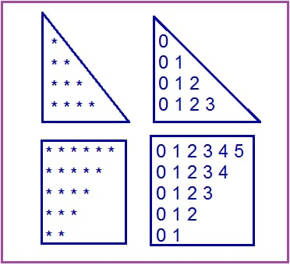

* Decide the number of rows and columns.

Accept the number of rows from a user using the input() function to decide the size of a pattern.

* Iterate rows.
* Iterate columns
* Print star or numberUse the print() function in each iteration of nested for loop to display the symbol or number of a pattern (like a star (asterisk \*) or number).
* Add new line after each iteration of outer loop
* Add a new line using the print() function after each iteration of the outer loop so that the pattern display appropriately

Program 1:

#Number pattern 1

n=int(input("Enter the number of rows:"))

for i in range(n):

for j in range(i):

print(i,end=" ")

print(" ")

Output 1:

Enter the number of rows:6

1

2 2

3 3 3

4 4 4 4

5 5 5 5 5

Program 2

#Number pattern 2

n=int(input("Enter the number of rows:"))

for i in range(1,n+1):

for j in range(1,i+1):

print(j,end=' ')

print(" ")

Output 2:

Enter the number of rows:5

1

1 2

1 2 3

1 2 3 4

1 2 3 4 5

Program 3:

#Number pattern 3

n=int(input("Enter the number of rows:"))

b=0

for i in range(n,0,-1):

b+=1

for j in range(1,i+1):

print(b,end=" ")

print('\r')

Output 3:

Enter the number of rows:5

1 1 1 1 1

2 2 2 2

3 3 3

4 4

5

Program 4:

#Number pattern 4

n=int(input("Enter the number of rows:"))

for i in range(n):

for j in range(i,n):

print('5',end=" ")

print()

Output 4 :

Enter the number of rows:5

5 5 5 5 5

5 5 5 5

5 5 5

5 5

5

Program 5:

#Number pattern 5

n=int(input("Enter the number of rows:"))

i=1

while(i<=n):

j=1

while(j<=i):

print((i\*2-1),end=" ")

j=j+1

i=i+1

print("")

Output 5:

Enter the number of rows:5

1

3 3

5 5 5

7 7 7 7

9 9 9 9 9

Program 6:

#Number pattern 6

n=int(input("Enter the number of rows:"))

for i in range(1,n+1):

for j in range(i,0,-1):

a=j

print(a,end=" ")

a=j+1

print(" ")

Output 6:

Enter the number of rows:5

1

2 1

3 2 1

4 3 2 1

5 4 3 2 1

3.PYRAMID PATTERN

Explanation:

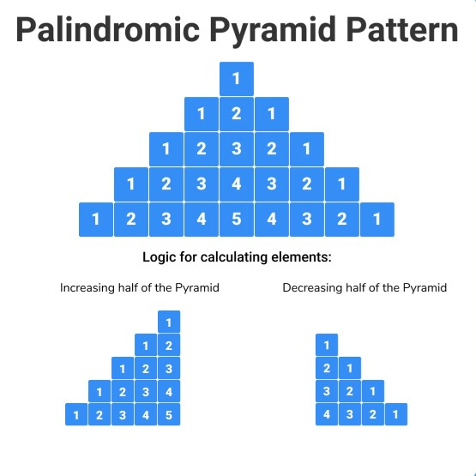

Program 1:

#Pyramid pattern 1

n=int(input("Enter the number of rows:"))

for i in range(0,n):

for j in range(0,i+1):

print('\*',end=" ")

print("\r")

Output:

Enter the number of rows:5

\*

\* \*

\* \* \*

\* \* \* \*

\* \* \* \* \*

Program 2:

#Pyramid pattern 2

n=int(input("Enter the number of rows:"))

for i in range(n+1,0,-1):

for j in range(0,i-1):

print('\*',end=" ")

print(" ")

Output 2:

Enter the number of rows:5

\* \* \* \* \*

\* \* \* \*

\* \* \*

\* \*

\*

Program 3:

#Pyramid pattern 3

n=int(input("Enter the number of rows:"))

for i in range(n):

for j in range(i):

print(" ",end="")

for j in range(n-i):

print("\*",end=" ")

print(" ")

Output 3:

Enter the number of rows:6

\* \* \* \* \* \*

\* \* \* \* \*

\* \* \* \*

\* \* \*

\* \*

\*

Program 4:

#Pyramid pattern 4

n=int(input("Enter the number of rows:"))

for i in range(n):

for j in range(i):

print(" ",end="")

for j in range(n-i):

print("\*",end=" ")

print(" ")

Output 4:

Enter the number of rows:5

\* \* \* \* \*

\* \* \* \*

\* \* \*

\* \*

\*

Program 5:

#Pyramid pattern 5

n=int(input("Enter the number of rows:"))

m=(2\*n)-2

for i in range(0,n):

for j in range(0,m):

print(end=" ")

m=m-1

for j in range(0,i+1):

print("\*",end=' ')

print(" ")

Output 5:

Enter the number of rows:6

\*

\* \*

\* \* \*

\* \* \* \*

\* \* \* \* \*

\* \* \* \* \* \*

Program 6:

#Pyramid pattern 6

n=int(input("Enter the number of rows:"))

for i in range(0,n):

for j in range(0,i+1):

print("\*",end=" ")

print("\r")

for i in range(n,0,-1):

for j in range(0,i-1):

print("\*",end=" ")

print("\r")

Output 6:

Enter the number of rows:5

\*

\* \*

\* \* \*

\* \* \* \*

\* \* \* \* \*

\* \* \* \*

\* \* \*

\* \*

\*

4.PROGRAMS ON CONDITIONS

Explanation:

Decimal numbers:

A decimal is a number that consists of a whole and a fractional part. Decimal numbers lie between integers and represent numerical value for quantities that are whole plus some part of a whole.

Binary numbers:

A binary number system is one of the four types of number system. In computer applications, where binary numbers are represented by only two symbols or digits, i.e. 0 (zero) and 1(one). The binary numbers here are expressed in the base-2 numeral system. For example, (101)2 is a binary number. Each digit in this system is said to be a bit.

Armstrong number:

An Armstrong number is a number such that the sum ! of its digits raised to the third power is equal to the number ! itself. For example, 371 is an Armstrong number, since ! 3\*\*3 + 7\*\*3 + 1\*\*3 = 371. !

Reversing a number:

Reversing a number means changing all the digits of a number to bring the digit at the last position to the first position and vice-versa

Prime number:

Prime numbers are numbers that have only 2 factors: 1 and themselves. For example, the first 5 prime numbers are 2, 3, 5, 7, and 11.

Leap year:

To be a leap year, the year number must be divisible by four – except for end-of-century years, which must be divisible by 400

Program 1:

#Decimal to binary

n=int(input("Enter the number:"))

sum=0

while(n>0):

r=n%2

sum=sum\*10+r

n=n//2

print(sum)

Output 1:

Enter the number:46

11101

Program 2:

#Binary to decimal

n=int(input("Enter the num:"))

num=n

sum=0

base=1

while(n>0):

rem=n%10

sum=sum+rem\*base

n=n//10

base=base\*2

print(sum)

Output 2:

Enter the num:1101

13

Program 3:

#Armstrong number

n=int(input("Enter the num:"))

num=n

sum=0

while(n>0):

rem=n%10

sum=sum+(rem\*\*3)

n=n//10

if(sum==num):

print("Armstrong number")

else:

print("Not Armstrong number")

Output 3:

Enter the num:153

Armstrong number

Program 4:

#Reversing a number

n=int(input("Enter the num:"))

num=n

sum=0

while(n>0):

rem=n%10

sum=(sum\*10)+rem

n=n//10

print(sum)

Output 4:

Enter the num:153

351

Program 5:

#Prime numbers between 1 to 50

start=int(input("Enter the lower bound:"))

stop=int(input("Enter the upper bound:"))

print("Prime numbers are:")

for n in range(start,stop):

if(n>1):

for i in range(2,n):

if(n%i)==0:

break

else:

print(n,end=" ")

Output 5:

Enter the lower bound:1

Enter the upper bound:50

Prime numbers are:

2 3 5 7 11 13 17 19 23 29 31 37 41 43 47

Program 6:

#Leap year between 1900 to 2000

start=int(input("Enter the lower bound year:"))

stop=int(input("Enter the higher bound year:"))

years=[]

for year in range(start,stop+1):

if (year%400==0):

years.append(year)

elif ((year%4==0)and(year%100!=0)):

years.append(year)

print(years)

Output 6:

Enter the lower bound year:1900

Enter the higher bound year:2000

[1904, 1908, 1912, 1916, 1920, 1924, 1928, 1932, 1936, 1940, 1944, 1948, 1952, 1956, 1960, 1964, 1968, 1972, 1976, 1980, 1984, 1988, 1992, 1996, 2000]

Web reference :

* Geeks for geeks
* Programiz
* Javatpoint
* CodesCracker
* Great Learning